WEEK 2

Aim
To design and develop a Static Campus Placement Application for Anil Neerukonda Institute of Technology & Sciences (ANITS) using HTML5 and CSS3, demonstrating semantic webpage structure, responsive layouts, navigation menus, forms, and attractive styling.

Description:
This experiment involves developing a static Campus Placement Application using only HTML5 and CSS3. The application is designed as a professional institutional placement portal that provides information about the Training and Placement Department, student registration, student login, participating companies, placement information, and contact details.
The application consists of interconnected webpages including Home, About, Student Registration, Registration Success, Student Login, Companies, and Contact pages. HTML5 semantic elements, hyperlinks, images, lists, tables, forms, HTML5 validation, and iframes are used to structure and organize the website. CSS3 is used to provide responsive layouts, Flexbox, backgrounds, gradients, hover effects, box shadows, border radius, transitions, and other styling features.
The website provides students with an interactive and well-organized interface for accessing campus placement-related information

Program code:
Index.html:
<!DOCTYPE html>
<html lang="en">
<head>
<meta charset="UTF-8">
<meta name="viewport" content="width=device-width, initial-scale=1.0">
<title>ANITS Placement Portal</title>
<link rel="stylesheet" href="style.css">
</head>
<body>

<!-- Header -->
<header>
<div class="top-header">
<img src="logo.png" alt="College Logo" class="logo">
<div class="header-text">
<h1>Anil Neerukonda Institute of Technology & Sciences</h1>
<h4>Campus Placement Portal</h4>
</div>
</div>

<!-- Navigation -->
<nav>
<ul>
<li><a href="index.html">Home</a></li>
<li><a href="about.html">About</a></li>
<li><a href="register.html">Register</a></li>
<li><a href="login.html">Login</a></li>
<li><a href="companies.html">Companies</a></li>
<li><a href="contact.html">Contact</a></li>
</ul>
</nav>
</header>

<!-- Hero Section -->
<section class="hero">
<video width="100%" height="500px" autoplay muted loop>
<source src="campus.jpg.mp4" type="video/mp4">
</video>
<div class="overlay-text">
"Welcome to ANITS Central Campus Recruitment"
</div>
</section>

<!-- Welcome Bar -->
<div class="welcome">
<marquee>
📢 Welcome to ANITS Central Placement Portal |
Admissions Open for 2026-27 |
Student Registration is Now Open |
Top Recruiters: TCS, Infosys, Wipro, Accenture, Cognizant, Capgemini, Amazon, Deloitte |
</marquee>
</div>

<!-- Statistics -->
<section class="stats">

<div class="card">
<h2>250+</h2>
<p>Recruiters</p>
</div>

<div class="card">
<h2>95%</h2>
<p>Placement Rate</p>
</div>

<div class="card">
<h2>35 LPA</h2>
<p>Highest Package</p>
</div>

<div class="card">
<h2>1200+</h2>
<p>Offers</p>
</div>

</section>

<!-- Footer -->
<footer>
© 2025 ANITS | Department of Training & Placement
</footer>

</body>
</html>
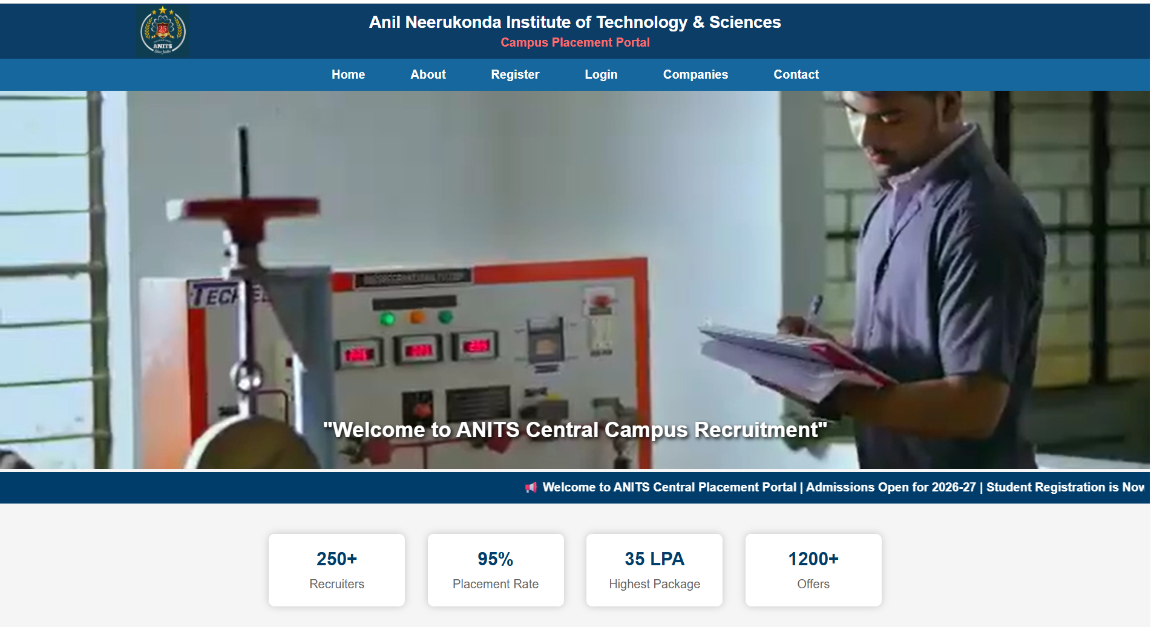
About.html:
<!DOCTYPE html>
<html lang="en">
<head>
<meta charset="UTF-8">
<meta name="viewport" content="width=device-width, initial-scale=1.0">
<title>About - ANITS Placement Portal</title>
<link rel="stylesheet" href="style.css">
</head>

<body>

<!-- Header -->
<header>
<div class="top-header">
<img src="logo.png" alt="College Logo" class="logo">

<div class="header-text">
<h1>Anil Neerukonda Institute of Technology & Sciences</h1>
<h4>Campus Placement Portal</h4>
</div>
</div>

<!-- Navigation -->
<nav>
<ul>
<li><a href="index.html">Home</a></li>
<li><a href="about.html">About</a></li>
<li><a href="register.html">Register</a></li>
<li><a href="login.html">Login</a></li>
<li><a href="companies.html">Companies</a></li>
<li><a href="contact.html">Contact</a></li>
</ul>
</nav>
</header>

<!-- About Section -->

<section class="about">

<h2>About the Training & Placement Department</h2>

<p>
<strong>Anil Neerukonda Institute of Technology & Sciences (ANITS)</strong>
has a dedicated Training & Placement Department headed by
<strong>Prof. P. Padmaja</strong> and supported by experienced faculty
coordinators. The department is committed to maximizing student
placements in both software and core engineering sectors through
continuous skill development and industry engagement.
</p>

<p>
ANITS provides comprehensive Campus Recruitment Training (CRT)
covering Quantitative Aptitude, Logical Reasoning, Verbal Reasoning,
English Communication, Group Discussions and Interview Skills.
These programs are conducted by experienced trainers to prepare
students for campus recruitment.
</p>

<p>
Recruiter feedback and alumni performance are regularly analyzed
to improve training strategies and align them with industry
requirements. The institute offers excellent placement
infrastructure including modern laboratories, seminar halls,
interview rooms and advanced computer facilities.
</p>

<p>
Through dedicated efforts and strong industry collaborations,
ANITS has consistently achieved an excellent placement record
with leading multinational companies visiting the campus every year.
</p>

<h3>Our Department Focuses On</h3>

<ul>
<li>Identifying employment opportunities for engineering graduates.</li>
<li>Building strong industry–academia partnerships.</li>
<li>Providing comprehensive Campus Recruitment Training (CRT).</li>
<li>Organizing expert lectures, workshops and seminars.</li>
<li>Conducting aptitude, coding and communication training.</li>
<li>Preparing students for Group Discussions and HR Interviews.</li>
<li>Facilitating internships and industrial visits.</li>
<li>Promoting innovation, entrepreneurship and career development.</li>
</ul>

</section>

<!-- Footer -->

<footer>
© 2025 ANITS | Department of Training & Placement
</footer>

</body>
</html>
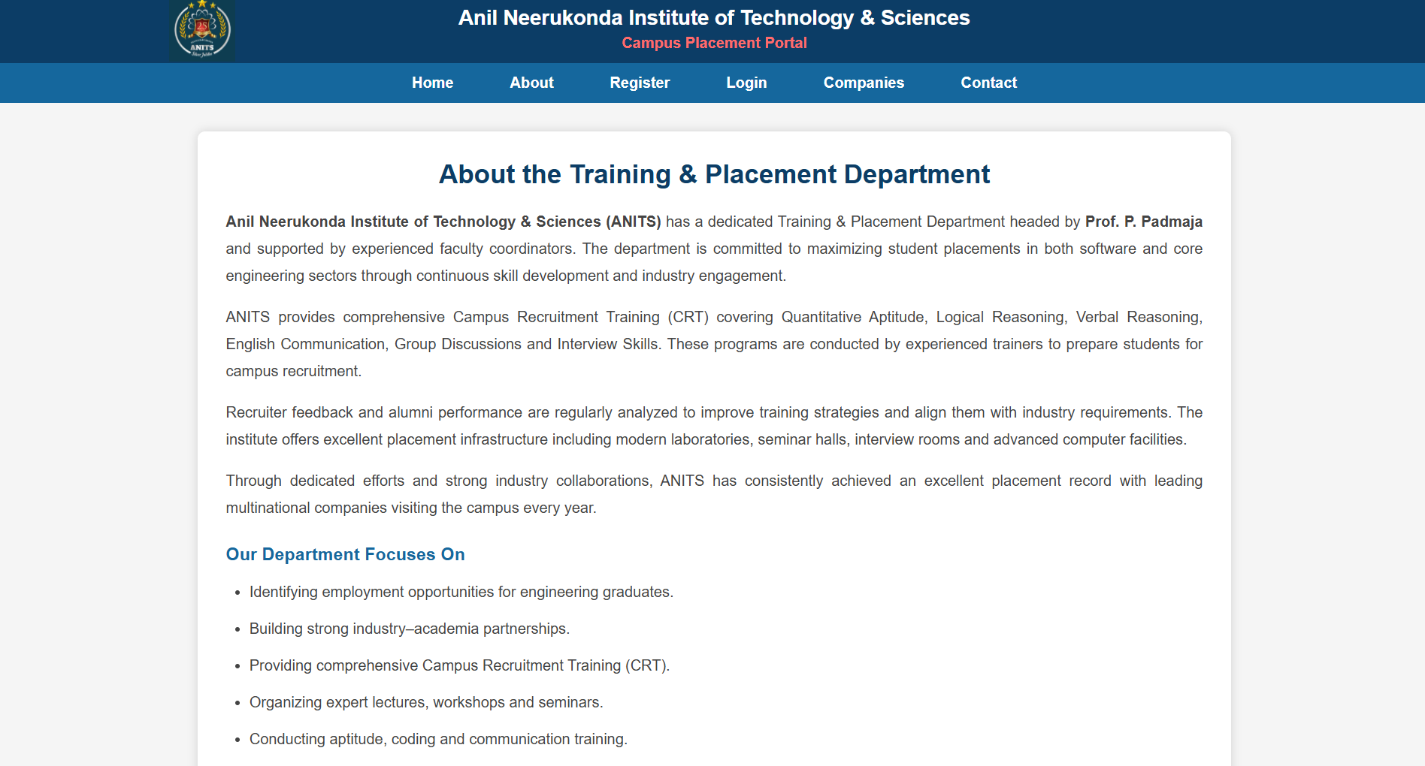
Companies.html:
<!DOCTYPE html>
<html lang="en">
<head>
<meta charset="UTF-8">
<meta name="viewport" content="width=device-width, initial-scale=1.0">
<title>Recruiting Companies</title>
<link rel="stylesheet" href="style.css">
</head>

<body>

<header>

<div class="top-header">
<img src="logo.png" alt="College Logo" class="logo">

<div class="header-text">
<h1>Anil Neerukonda Institute of Technology & Sciences</h1>
<h4>Campus Placement Portal</h4>
</div>
</div>

<nav>
<ul>
<li><a href="index.html">Home</a></li>
<li><a href="about.html">About</a></li>
<li><a href="register.html">Register</a></li>
<li><a href="login.html">Login</a></li>
<li><a href="companies.html">Companies</a></li>
<li><a href="contact.html">Contact</a></li>
</ul>
</nav>

</header>

<div class="companies">

<h2>Recruiting Companies</h2>

<table class="company-table">

<tr>
<th>Company</th>
<th>Role</th>
<th>Package</th>
</tr>

<tr>
<td>MAANG Companies</td>
<td>SDE</td>
<td>Min 40 LPA</td>
</tr>

<tr>
<td>TCS</td>
<td>Software Engineer</td>
<td>7 LPA</td>
</tr>

<tr>
<td>Infosys</td>
<td>System Engineer</td>
<td>6.5 LPA</td>
</tr>

<tr>
<td>Accenture</td>
<td>Associate</td>
<td>6 LPA</td>
</tr>

<tr>
<td>Cognizant</td>
<td>Programmer Analyst</td>
<td>6 LPA</td>
</tr>

</table>

<div class="placement-box">

<h3>Placement Highlights 2025</h3>

<div class="highlight-row">

<div class="highlight-card">
<h2>1095+</h2>
<p>Job Offers</p>
</div>

<div class="highlight-card">
<h2>12 LPA</h2>
<p>Highest Package</p>
</div>

<div class="highlight-card">
<h2>5.06 LPA</h2>
<p>Average Package</p>
</div>

<div class="highlight-card">
<h2>63</h2>
<p>Total Companies</p>
</div>

</div>

</div>

<div class="placement-box">

<h3>Placement Highlights 2024</h3>

<div class="highlight-row">

<div class="highlight-card">
<h2>1143</h2>
<p>Job Offers</p>
</div>

<div class="highlight-card">
<h2>48 LPA</h2>
<p>Highest Package</p>
</div>

<div class="highlight-card">
<h2>5.26 LPA</h2>
<p>Average Package</p>
</div>

<div class="highlight-card">
<h2>83</h2>
<p>Total Companies</p>
</div>

</div>

</div>

</div>

<footer>
© 2025 ANITS | Department of Training & Placement
</footer>

</body>
</html>
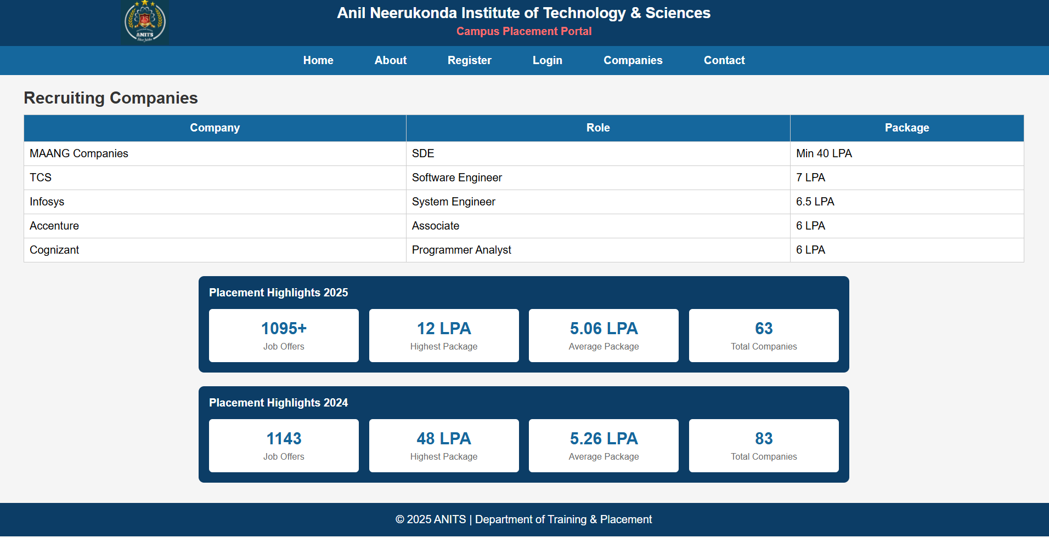
Contact.html:
<!DOCTYPE html>
<html lang="en">
<head>
<meta charset="UTF-8">
<meta name="viewport" content="width=device-width, initial-scale=1.0">
<title>Contact - ANITS Placement Portal</title>
<link rel="stylesheet" href="style.css">
</head>

<body>

<header></header>
<div class="top-header">
<img src="logo.png" alt="College Logo" class="logo">

<div class="header-text">
<h1>Anil Neerukonda Institute of Technology & Sciences</h1>
<h4>Campus Placement Portal</h4>
</div>
</div>

<nav>
<ul>
<li><a href="index.html">Home</a></li>
<li><a href="about.html">About</a></li>
<li><a href="register.html">Register</a></li>
<li><a href="login.html">Login</a></li>
<li><a href="companies.html">Companies</a></li>
<li><a href="contact.html">Contact</a></li>
</ul>
</nav>

</header>

<div class="contact-container">

<h2>Contact Placement Cell</h2>

<p><strong>Email:</strong> placements@anits.edu.in</p>

<p><strong>Phone:</strong> +91-9876543210</p>

<div class="map">

<iframe
src="https://www.google.com/maps?q=Anil%20Neerukonda%20Institute%20of%20Technology%20and%20Sciences&output=embed"
width="500"
height="350"
style="border:0;"
allowfullscreen=""
loading="lazy">
</iframe>

</div>

</div>

<footer>
© 2025 ANITS | Department of Training & Placement
</footer>

</body>
</html>
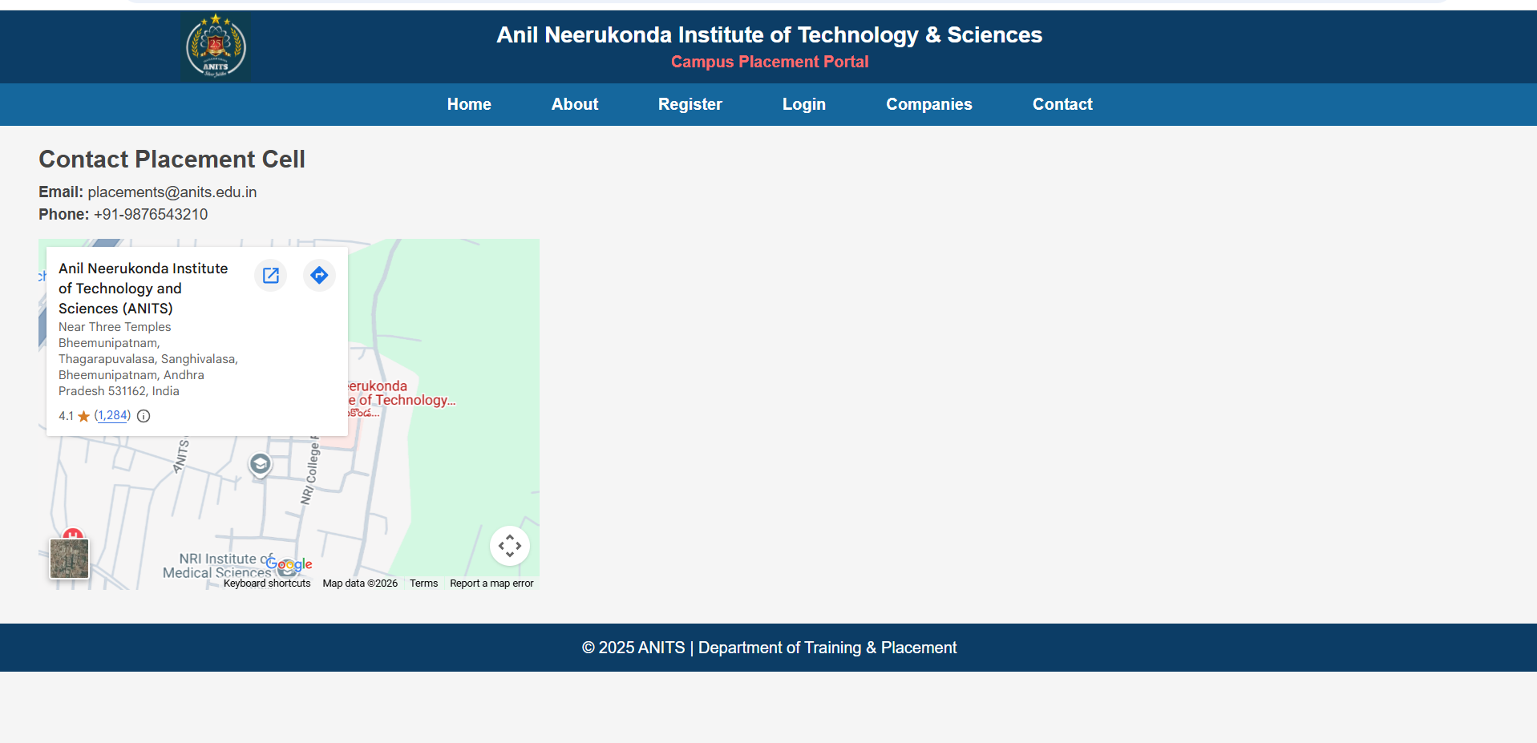
Login.html:
<!DOCTYPE html>
<html lang="en">
<head>
<meta charset="UTF-8">
<meta name="viewport" content="width=device-width, initial-scale=1.0">
<title>Student Login</title>
<link rel="stylesheet" href="style.css">
</head>

<body>

<!-- Header -->

<header>

<div class="top-header">

<img src="logo.png" alt="College Logo" class="logo">

<div class="header-text">
<h1>Anil Neerukonda Institute of Technology & Sciences</h1>
<h4>Campus Placement Portal</h4>
</div>

</div>

<nav>
<ul>
<li><a href="index.html">Home</a></li>
<li><a href="about.html">About</a></li>
<li><a href="register.html">Register</a></li>
<li><a href="login.html">Login</a></li>
<li><a href="companies.html">Companies</a></li>
<li><a href="contact.html">Contact</a></li>
</ul>
</nav>

</header>

<!-- Login Form -->

<div class="login-container">

<h2>Student Login</h2>

<form>

<table class="login-table">

<tr>
<td>Username</td>
</tr>

<tr>
<td>
<input type="text" placeholder="Enter Username" required>
</td>
</tr>

<tr>
<td>Password</td>
</tr>

<tr>
<td>
<input type="password" placeholder="Enter Password" required>
</td>
</tr>

</table>

<button type="submit" class="login-btn">
Login
</button>

</form>

</div>

<!-- Footer -->

<footer>
© 2025 ANITS | Department of Training & Placement
</footer>

</body>
</html>
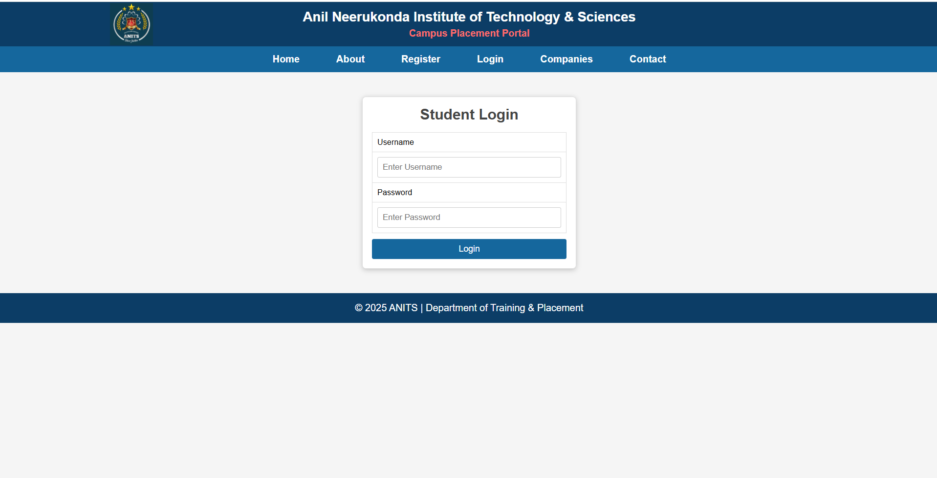
Register.html:
<!DOCTYPE html>
<html lang="en">
<head>
<meta charset="UTF-8">
<meta name="viewport" content="width=device-width, initial-scale=1.0">
<title>Student Registration - ANITS Placement Portal</title>
<link rel="stylesheet" href="style.css">
</head>

<body>

<!-- Header -->
<header>

<div class="top-header">
<img src="logo.png" alt="College Logo" class="logo">

<div class="header-text">
<h1>Anil Neerukonda Institute of Technology & Sciences</h1>
<h4>Campus Placement Portal</h4>
</div>
</div>

<!-- Navigation -->
<nav>
<ul>
<li><a href="index.html">Home</a></li>
<li><a href="about.html">About</a></li>
<li><a href="register.html">Register</a></li>
<li><a href="login.html">Login</a></li>
<li><a href="companies.html">Companies</a></li>
<li><a href="contact.html">Contact</a></li>
</ul>
</nav>

</header>

<!-- Registration Form -->

<div class="register-container">

<h2>Student Registration</h2>

<form>

<fieldset>

<legend>Personal Information</legend>

<table class="register-table">

<tr>
<td>Full Name</td>
<td><input type="text" placeholder="Enter your full name"></td>
</tr>

<tr>
<td>Password</td>
<td><input type="password" placeholder="Enter password"></td>
</tr>

<tr>
<td>Email Address</td>
<td><input type="email" placeholder="abc@example.com"></td>
</tr>

<tr>
<td>Mobile Number</td>
<td><input type="tel" placeholder="9876543210"></td>
</tr>

<tr>
<td>Age</td>
<td><input type="number"></td>
</tr>

<tr>
<td>Date of Birth</td>
<td><input type="date"></td>
</tr>

<tr>
<td>Preferred Time</td>
<td><input type="time"></td>
</tr>

<tr>
<td>Registration Date & Time</td>
<td><input type="datetime-local"></td>
</tr>

</table>

</fieldset>

<fieldset>

<legend>Academic Information</legend>

<table class="register-table">

<tr>
<td>Department</td>
<td>
<select>
<option>Computer Science</option>
<option>Information Technology</option>
<option>ECE</option>
<option>EEE</option>
<option>Mechanical</option>
<option>Civil</option>
</select>
</td>
</tr>

<tr>
<td>Programming Language</td>
<td>
<label><input type="checkbox"> C</label><br>
<label><input type="checkbox"> C++</label><br>
<label><input type="checkbox"> Java</label><br>
<label><input type="checkbox"> Python</label>
</td>
</tr>

<tr>
<td>Gender</td>
<td>
<label><input type="radio" name="gender"> Male</label><br><br>
<label><input type="radio" name="gender"> Female</label><br><br>
<label><input type="radio" name="gender"> Other</label>
</td>
</tr>

<tr>
<td>Skills</td>
<td>
<label><input type="checkbox"> HTML</label><br><br>
<label><input type="checkbox"> CSS</label><br><br>
<label><input type="checkbox"> JavaScript</label><br><br>
<label><input type="checkbox"> Java</label><br><br>
<label><input type="checkbox"> Python</label>
</td>
</tr>

</table>

</fieldset>

<fieldset>

<legend>Online Information</legend>

<table class="register-table">

<tr>
<td>Portfolio Website</td>
<td><input type="url" placeholder="https://example.com"></td>
</tr>

<tr>
<td>Search Course</td>
<td><input type="search" placeholder="Search course"></td>
</tr>

<tr>
<td>Upload Resume</td>
<td><input type="file"></td>
</tr>

<tr>
<td>Programming Skill Level</td>
<td>
<input type="range" min="0" max="100" value="50">
<div class="level">
<span>Beginner</span>
<span>Expert</span>
</div>
</td>
</tr>

<tr>
<td>Address</td>
<td>
<textarea placeholder="Enter your address"></textarea>
</td>
</tr>

</table>

</fieldset>

<p class="declaration">
<input type="checkbox" required>
I hereby declare that the information provided above is true and correct.
</p>

<button type="submit" class="register-btn">Register</button>

<button type="reset" class="reset-btn">Reset</button>

</form>

</div>

<!-- Footer -->

<footer>
© 2025 ANITS | Department of Training & Placement
</footer>

</body>
</html>
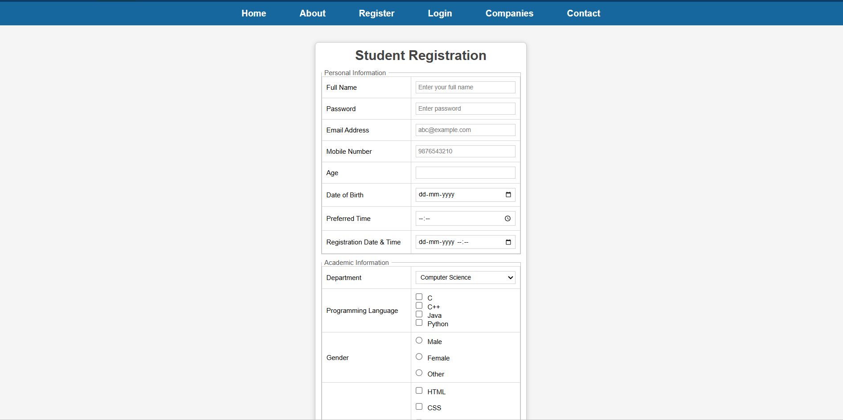
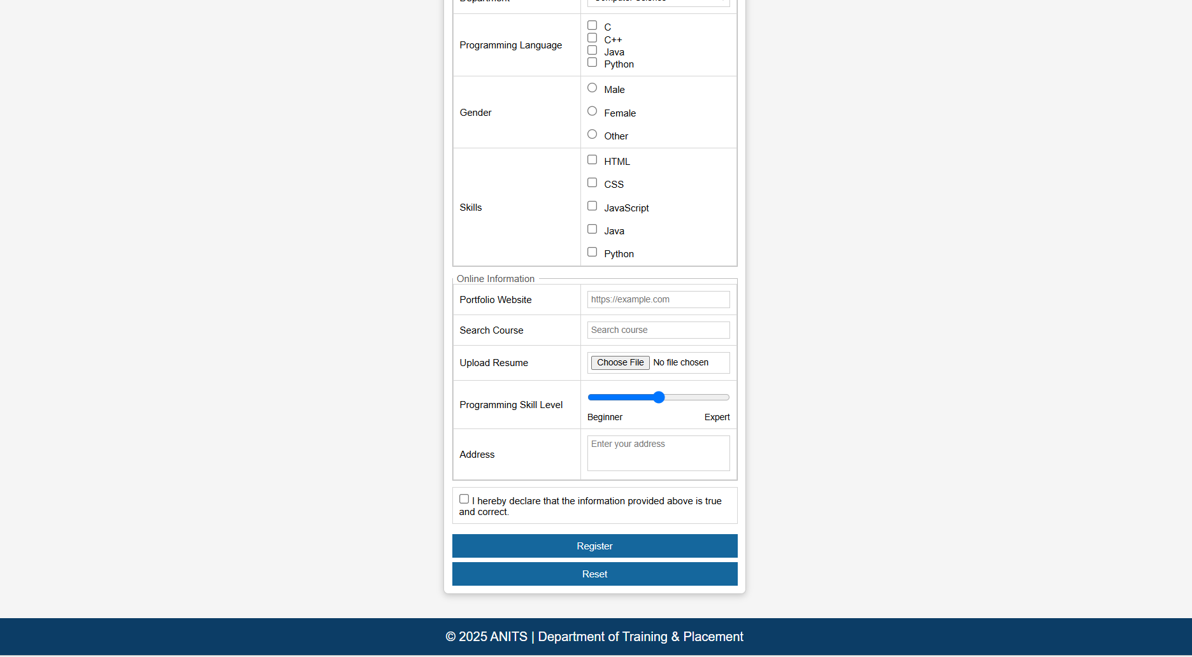
Success.html:
<!DOCTYPE html>
<html lang="en">
<head>
<meta charset="UTF-8">
<meta name="viewport" content="width=device-width, initial-scale=1.0">
<title>Registration Successful</title>
<link rel="stylesheet" href="style.css">
</head>

<body>

<!-- Header -->

<header>

<div class="top-header">
<img src="logo.png" alt="College Logo" class="logo">

<div class="header-text">
<h1>Anil Neerukonda Institute of Technology & Sciences</h1>
<h4>Campus Placement Portal</h4>
</div>
</div>

<nav>
<ul>
<li><a href="index.html">Home</a></li>
<li><a href="about.html">About</a></li>
<li><a href="register.html">Register</a></li>
<li><a href="login.html">Login</a></li>
<li><a href="companies.html">Companies</a></li>
<li><a href="contact.html">Contact</a></li>
</ul>
</nav>

</header>

<!-- Success Box -->

<div class="success-box">

<h2>Registration Successful!</h2>

<h3>Welcome to ANITS Central Placement Portal</h3>

<p>
Congratulations! Your registration has been completed successfully.
Your profile has been submitted to the Training & Placement Department.
</p>

<div class="notice">

<h4>📢 Important Notice</h4>

<p>Please contact the <b>Training & Placement Office</b> regularly for updates.</p>

<ul>
<li>Stay informed about the latest MAANG Companies Recruitment Process.</li>
<li>Check your registered Email ID and Placement Portal for announcements.</li>
<li>Attend all Pre-Placement Talks (PPTs), Aptitude Training, Mock Interviews, and Company Drives.</li>
<li>Keep your Resume, Academic Documents, and ID Card ready before every recruitment process.</li>
</ul>

</div>

</div>

<!-- Footer -->

<footer>
© 2025 ANITS | Department of Training & Placement
</footer>

</body>
</html>

Style.css:
*{
margin:0;
padding:0;
box-sizing:border-box;
font-family:Arial, Helvetica, sans-serif;
}

body{
background:#f5f5f5;
}

/*======================
HEADER
=======================*/

.top-header{
background:#0c3d66;
color:white;
display:flex;
justify-content:center;
align-items:center;
gap:20px; /* Space between logo and text */
padding:12px 20px;
}

.logo{
width:70px;
height:70px;
position:absolute;
left:180px; /* Adjust this value */
}

.header-text{
text-align:center;
}

.header-text h1{
font-size:22px;
font-weight:bold;
}

.header-text h4{
margin-top:5px;
color:#ff6b6b;
}

/*======================
NAVIGATION
=======================*/

nav{
background:#15679d;
}

nav ul{
list-style:none;
display:flex;
justify-content:center;
}

nav li{
margin:0 18px;
}

nav a{
display:block;
padding:12px;
color:white;
text-decoration:none;
font-weight:bold;
}

nav a:hover{
background:#0a4c75;
}

/*======================
HERO SECTION
=======================*/

.hero{
position:relative;
}

.hero video,
.hero img{
width:100%;
height:500px;
object-fit:cover;
}

.overlay-text{
position:absolute;
bottom:40px;
width:100%;
text-align:center;
color:white;
font-size:28px;
font-weight:bold;
text-shadow:2px 2px 5px black;
}

/*======================
MARQUEE
=======================*/

.welcome{
background:#003d6b;
color:white;
padding:8px;
font-weight:bold;
}

/*======================
STATISTICS
=======================*/

.stats{
display:flex;
justify-content:center;
gap:30px;
padding:40px;
flex-wrap:wrap;
}

.card{
width:180px;
background:white;
border-radius:8px;
box-shadow:0 0 10px rgba(0,0,0,.2);
text-align:center;
padding:20px;
}

.card h2{
color:#003d6b;
margin-bottom:10px;
}

.card p{
color:#666;
}

/*======================
ABOUT PAGE
=======================*/

.about{
width:90%;
max-width:1100px;
margin:30px auto;
background:white;
padding:30px;
border-radius:8px;
box-shadow:0 0 10px rgba(0,0,0,0.15);
}

.about h2{
color:#0c3d66;
text-align:center;
margin-bottom:20px;
font-size:28px;
}

.about h3{
color:#15679d;
margin-top:25px;
margin-bottom:15px;
}

.about p{
font-size:16px;
color:#444;
line-height:1.8;
text-align:justify;
margin-bottom:15px;
}

.about ul{
margin-left:25px;
margin-top:10px;
}

.about ul li{
margin-bottom:12px;
line-height:1.7;
color:#444;
}

/*======================
FOOTER
=======================*/

footer{
background:#0c3d66;
color:white;
text-align:center;
padding:15px;
margin-top:30px;
}

/*======================
RESPONSIVE
=======================*/

@media(max-width:768px){

.top-header{
flex-direction:column;
padding-top:80px;
}

.logo{
position:static;
margin-bottom:10px;
}

.header-text h1{
font-size:18px;
}

nav ul{
flex-direction:column;
}

nav li{
margin:0;
}

.hero video,
.hero img{
height:250px;
}

.overlay-text{
font-size:18px;
}

.stats{
flex-direction:column;
align-items:center;
}

.about{
width:95%;
padding:20px;
}

.about h2{
font-size:22px;
}

}
/*======================
REGISTER PAGE
=======================*/

.register-container{
width:380px;
margin:30px auto;
background:#fff;
border:1px solid #ccc;
border-radius:6px;
box-shadow:0 2px 8px rgba(0,0,0,.2);
padding:10px;
}

.register-container h2{
text-align:center;
margin-bottom:10px;
color:#444;
}

fieldset{
border:1px solid #bdbdbd;
margin-bottom:8px;
padding:0;
}

legend{
font-size:12px;
color:#555;
padding:0 5px;
}

.register-table{
width:100%;
border-collapse:collapse;
}

.register-table td{
border:1px solid #d5d5d5;
padding:8px;
font-size:12px;
}

.register-table td:first-child{
width:45%;
}

.register-table input,
.register-table select,
.register-table textarea{
width:100%;
border:1px solid #cfcfcf;
padding:4px;
font-size:11px;
}

.register-table textarea{
height:45px;
resize:none;
}

.register-table input[type="checkbox"],
.register-table input[type="radio"]{
width:auto;
margin-right:5px;
}

.register-table input[type="range"]{
width:100%;
}

.level{
display:flex;
justify-content:space-between;
font-size:11px;
margin-top:4px;
}

.declaration{
border:1px solid #d5d5d5;
padding:8px;
font-size:12px;
margin-bottom:8px;
}

.register-btn,
.reset-btn{
width:100%;
background:#15679d;
color:white;
border:none;
padding:8px;
margin-top:5px;
cursor:pointer;
font-size:12px;
}

.register-btn:hover,
.reset-btn:hover{
background:#0c3d66;
}
/*======================
SUCCESS PAGE
=======================*/

.success-box{
width:700px;
margin:40px auto;
background:#fff;
padding:35px;
border-radius:8px;
box-shadow:0 0 10px rgba(0,0,0,0.2);
text-align:center;
}

.success-box h2{
color:#1f8b2d;
margin-bottom:8px;
}

.success-box h3{
color:#0c3d66;
margin-bottom:15px;
font-size:20px;
}

.success-box p{
color:#555;
line-height:1.7;
}

.notice{
margin-top:25px;
text-align:left;
background:#fff8e8;
border-left:5px solid orange;
padding:15px 20px;
}

.notice h4{
color:#d35400;
margin-bottom:10px;
}

.notice ul{
margin-left:20px;
}

.notice li{
margin-bottom:8px;
color:#444;
}

@media(max-width:768px){

.success-box{
width:95%;
padding:20px;
}

}
/*======================
LOGIN PAGE
=======================*/

.login-container{
width:350px;
margin:40px auto;
background:#fff;
border:1px solid #ddd;
border-radius:6px;
box-shadow:0 2px 8px rgba(0,0,0,0.2);
padding:15px;
}

.login-container h2{
text-align:center;
color:#444;
margin-bottom:15px;
}

.login-table{
width:100%;
border-collapse:collapse;
}

.login-table td{
border:1px solid #ddd;
padding:8px;
font-size:13px;
}

.login-table input{
width:100%;
padding:8px;
border:1px solid #ccc;
border-radius:3px;
}

.login-btn{
width:100%;
margin-top:10px;
padding:8px;
border:none;
background:#15679d;
color:white;
border-radius:3px;
cursor:pointer;
font-size:14px;
}

.login-btn:hover{
background:#0c3d66;
}

@media(max-width:768px){

.login-container{
width:95%;
}

}
/*======================
COMPANIES PAGE
=======================*/

.companies{
width:95%;
margin:20px auto;
}

.companies h2{
color:#333;
margin-bottom:10px;
}

.company-table{
width:100%;
border-collapse:collapse;
background:white;
}

.company-table th{
background:#15679d;
color:white;
padding:10px;
border:1px solid #ccc;
}

.company-table td{
padding:8px;
border:1px solid #ccc;
}

.placement-box{
width:65%;
margin:20px auto;
background:#0c3d66;
border-radius:8px;
padding:15px;
}

.placement-box h3{
color:white;
margin-bottom:15px;
font-size:16px;
}

.highlight-row{
display:flex;
justify-content:space-between;
gap:15px;
}

.highlight-card{
flex:1;
background:white;
border-radius:5px;
text-align:center;
padding:15px;
}

.highlight-card h2{
color:#15679d;
margin-bottom:5px;
}

.highlight-card p{
color:#666;
font-size:13px;
}

@media(max-width:768px){

.highlight-row{
flex-direction:column;
}

.placement-box{
width:95%;
}

}
/*======================
CONTACT PAGE
=======================*/

.contact-container{
width:95%;
margin:20px auto;
}

.contact-container h2{
color:#444;
margin-bottom:10px;
}

.contact-container p{
margin:5px 0;
color:#444;
font-size:15px;
}

.map{
margin-top:15px;
}

.map iframe{
width:500px;
height:350px;
border:1px solid #ccc;
}

@media(max-width:768px){

.map iframe{
width:100%;
height:300px;
}

}
Result:
The Static Campus Placement Application for ANITS was successfully designed and developed using HTML5 and CSS3. The application includes interconnected webpages for Home, About, Student Registration, Registration Success, Student Login, Companies, and Contact. The project demonstrates semantic HTML elements, navigation, forms, tables, responsive design, and CSS styling to create a professional static placement portal.

